Experiment 4

Write a program for encryption and decryption of text

Program:

#include <stdio.h>

#include <ctype.h>

#include <conio.h>

#define MAX 1000

int main() {

{int s, pi, ci;

char plain[MAX], cipher[MAX];

printf("\*\*\*Encryption & decryption using substitution cipher\*\*\*\n\n");

printf("Enter the plain text:\n");

gets(plain);

while(1) {

printf("\nKey (number of shifts per character) for encryption : ");

scanf("%d", &s);

if(s < 1 || s> 25)

printf("Bad input! Enter a value between 1 and 25.");

else

break;}

printf("\nAfter removing non alphabetic characters and capitalizing:\n");

for(ci = 0, pi=0; plain[pi] != '\0'; pi++)

if(isalpha(plain[pi])) {

putchar(toupper(plain[pi]));

cipher[ci++]=((toupper(plain[pi]) - 'A')+s%26)%26 + 'A';}

cipher[ci] ='\0';

printf("\n\nAfter encryption:\n%s\n", cipher);

while(1) {

printf("\n Key for decryption : ");

scanf("%d", &s);

if(s<1 || s> 25)

printf("Bad input! Enter a value between 1 and 25.");

else

break;}

for(pi=0, ci=0; cipher[ci]!='\0'; ci++)

plain[pi++]=((cipher[ci] - 'A') + (26 - s)) % 26+ 'A';

plain[pi] = '\0';

printf("\After decryption:\n%s", plain);}

getch();

}

Algorithm:

* Take input data string and key, where 0<key<26
* Remove non-alphabetic characters, capitalize the letters and display new string
* To encrypt, subtract ‘A’ from each alphabet to get index, add key modulo 26, and add it back to ‘A’ to get cipher text alphabet
* Take input key for decryption, where 0<key<26
* To decrypt, subtract ‘A’ for index, add (26-key) for decryption, and add ’A’ to get back the letter

Output:

(Plain text = RAMA, Key = 4)

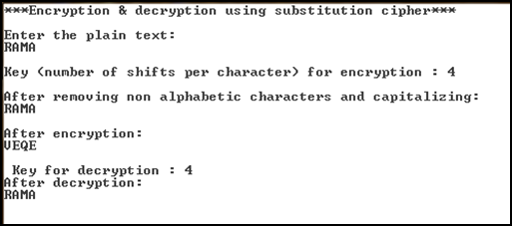

(Plain text = RAMA, incorrect decryption key)

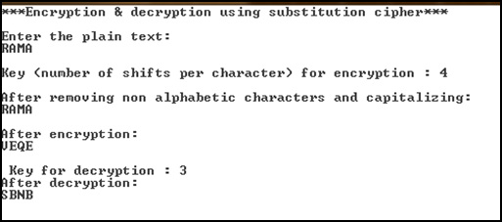

(Plain text = abc.def ghi, Key = 5)

